Exercise 2: Verifying Interactions
Scenario: You need to ensure that a method is called with specific arguments.

Printer.java
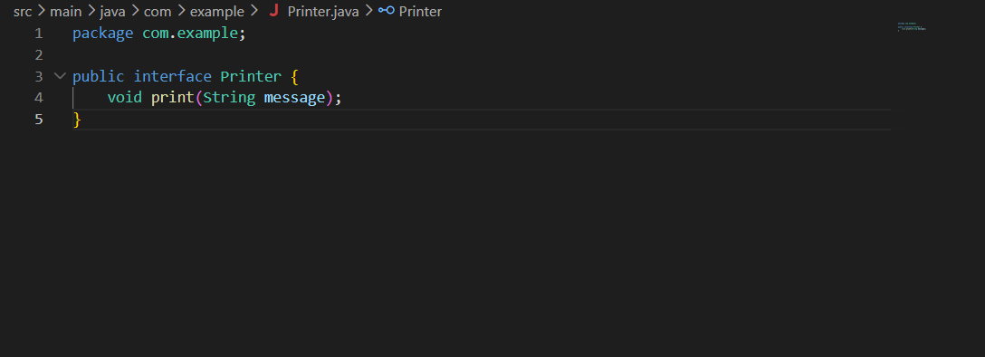
MessageService.java
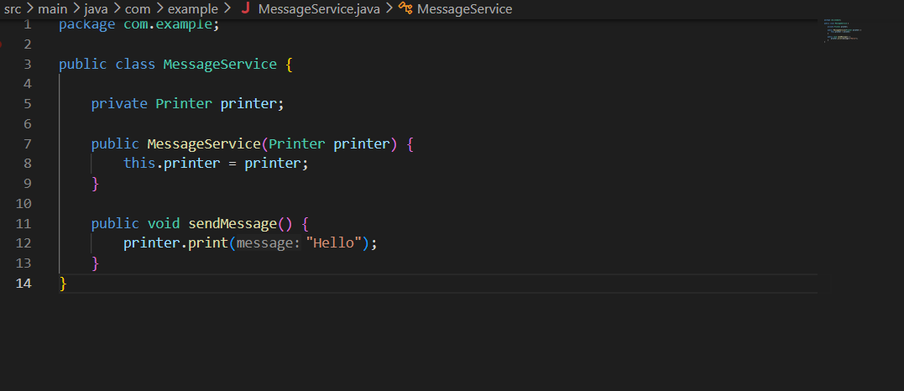

MessageServiceTest.java
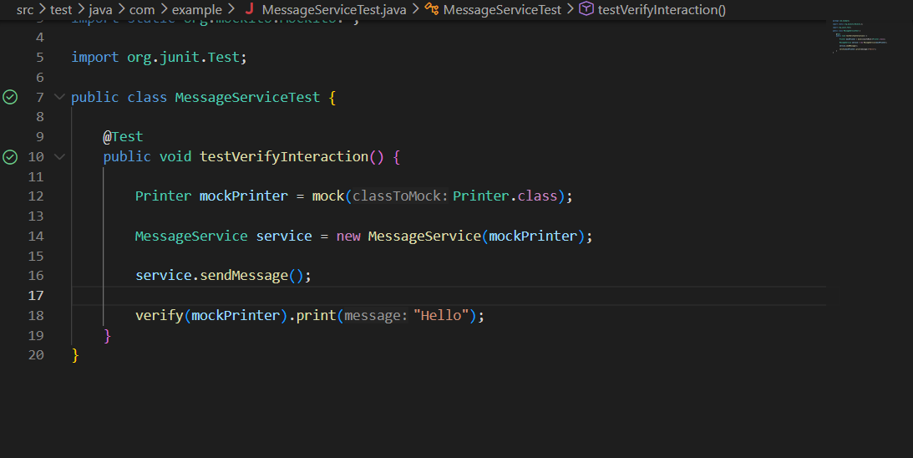
Output
